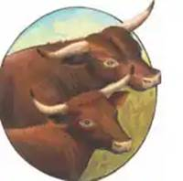
American Milking Devon Cattle Association

Ray Clark Memorial Award
The $1,000 Ray Clark Memorial Award is sponsored by the American Milking Devon Cattle Association (AMDCA) in honor of Ray and his lifetime dedication to preserving the Breed and his willingness to assist all interested parties in learning about the Breed. This Award will be awarded to a direct family member of the AMDCA to be applied to either post-secondary expenses or other specific career expenses. The applicant must complete and submit the PDF form by February 1st and the Board will make a decision by March 31st. The Award will be issued May 1st, 2026.
Please contact the AMDCA secretary (Bruce Farr, Farrviewsouthfarm@yahoo.com) with questions.

Name:

Address:

Email:

Phone Number:
Essay Questions:
(These answers should be less than 500 words and provide the judges with a clear picture of your interest in and future plans for working with Devon Cattle)
How did you get interested in and what has been your experience with American Milking Devon Cattle?

How has working with Devon cattle benefited you?

What are your future career plans and how do Devon cattle fit into those plans?

How do you plan on using these funds if you are the recipient? (Post-secondary expenses or if for other career expenses describe what those expenses will be)

Examples: Tuition at a Post-secondary school, Fees for ABS training/CDL A license, diesel diagnostic specialty equipment)

